cnc_searchresult

声明
/* line edit (search string) */
[DllImport("FWLIB32.dll", EntryPoint="cnc_searchresult")]
public static extern short cnc_searchresult( ushort FlibHndl, out uint a );

描述
搜索NC程序中的字符。
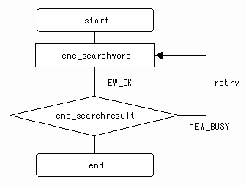

参数
（1）FlibHndl 库句柄；[ in ]

函数返回值
函数运行正常返回EW_OK。
Return code | Meaning/Error handling
EW_BUSY  (-1) | Busy  - except 30i/31i/32i, 0i-D, PMi-A  Some alarm has existed or CNC is searching the program text right now.  - 30i/31i/32i, 0i-D, PMi-A  CNC is searching the program text right now.
EW_FUNC  (1) | cnc_searchword function was not called prior to this function
EW_NUMBER  (3) | Data number error  The line number from which is started to search is not found.
EW_DATA  (5) | Data error  The target string to search is not found.
EW_NOOPT  (6) | no option  The extended driver/library function is necessary.

代码

